OFFICIAL COORDINATION REQUEST FOR
NON-ROUTINE OPERATIONS AND MAINTENANCE

COORDINATION DATE- 14 March 2011 Updated 22 March 2011
PROJECT- John Day Dam
RESPONSE DATE- 17 March 2011

Description of the problem- The JDA-N crowder light box has filled with about 200 gallons of river water. See picture below. If left in this condition, the warranty may be voided, algae may grow inside the box, and fish counts may be impacted. Construction believes they may be able to get the contractor on site by 21 March to make repairs. To make repairs, the upper section of the north fish ladder will need to be dewatered outside the normal winter maintenance period.

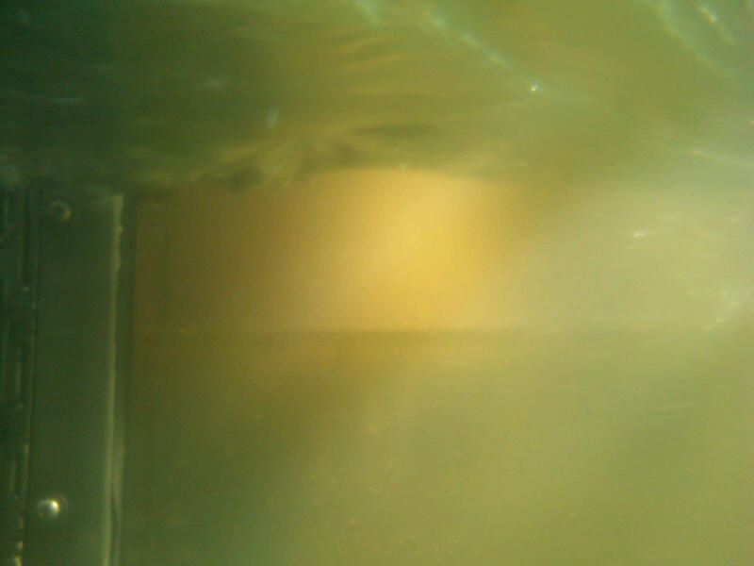
JDA-N crowder light box- March 2011.

Type of outage required- The upper section of the north fish ladder would need to be dewatered for one day.

Impact on facility operation- The north Fishladder would be out of service on 21 March. Construction believes the work will be completed in one day. The ladder would need to be dewatered to tailwater to allow contractor access to the crowder.

Length of time for repairs- One day.
Expected impacts on fish passage- March fish counts, by ladder, for JDA were available from 2003-2007. Below is a table showing fish numbers, by ladder and year for 14-28 March.

Table 1. JDA chinook and steelhead passage numbers for 14-28 March from 2003-2007.
 | 2003 | 2004 | 2005 | 2006 | 2007
JDA-N CH | 2288 | 39 | 10 | 0 | 0
JDA-S CH | 313 | 49 | 5 | 0 | 0
JDA-N STHD | 3183 | 606 | 855 | 785 | 909
JDA-S STHD | 1345 | 894 | 365 | 23 | 976
Table 2. JDA chinook and steelhead passage numbers for April 1 2008-2010
 | 4/1/2008 | 4/1/2009 | 4/1/2010
JDA-N CH | 0 | 4 | NA
JDA-S CH | 5 | 2 | NA
JDA-N STHD | 16 | 60 | 48
JDA-S STHD | 23 | 35 | 126

Based on the Table 1 above, steelhead are going to be impacted most since there are more of them and they appear to favor the north ladder more consistently, however, the south ladder will remain open so fish will have a passage route. There will be delayed associated with fish on the north side scouting for a passage on the south shore.

If the counts are broken down into daily counts, the numbers tend to increase as the month progresses. To minimize the impacts to as few fish as possible, NWP Fisheries recommends moving forward with repairs as soon as possible.

Looking at just passage numbers for 21 March, as per the fish count website, about 100 steelhead may be delayed by taking JDA-N out of service for a day. Compared with the potential impacts to fish counts throughout the season, if repairs are delayed or the crowder light box fails in other ways due to flooding, taking JDA-N out of service on 21 March seems a relatively low impact option.

Comments from agencies
NWP PM-E (Tackley)- -----Original Message-----

From: Tackley, Sean C NWP
Sent: Monday, March 14, 2011 3:23 PM
To: Mackey, Tammy M NWP; Hurd, Terry W NWP; Galanopoulos, Harilaos C NWP
Subject: RE: FPOM: MOC draft
From a passage perspective, the sooner we can get this done, the better. -Sean

WDFW- -----Original Message-----
From: Stephenson, Ann E (DFW) [mailto:Ann.Stephenson@dfw.wa.gov]
Sent: Monday, March 14, 2011 4:37 PM
To: Mackey, Tammy M NWP
Subject: RE: FPOM: Official Coordination for JDA-N crowder light box

I agree that it needs to be done as soon as possible. Absolutely before April 1. Any idea how this happened and how it can be prevented in the future? Ann

Ann E. Stephenson
Fish and Wildlife Biologist III
Portland District Adult Fish Counting
Washington Dept. of Fish and Wildlife
P.O. Box 41, White Salmon, WA 98672
(360) 600-8274
stephaes@dfw.wa.gov <mailto:stephaes@dfw.wa.gov>

IDFG- -----Original Message-----
From: Kiefer,Russell [mailto:russ.kiefer@idfg.idaho.gov]
Sent: Wednesday, March 16, 2011 3:25 PM
To: Mackey, Tammy M NWP
Subject: RE: FPOM: Official Coordination for JDA-N crowder light box

Tammy,
We have no objections. Russ
CRITFC- -----Original Message-----
From: Tom Lorz [mailto:lort@critfc.org]
Sent: Monday, March 14, 2011 6:16 PM
To: Mackey, Tammy M NWP
Subject: Re: FPOM: Official Coordination for JDA-N crowder light box

You should also have 2008 through 2010 adult counts in the form at least what they were at April 1st if we do not have before. Looking at numbers this year we are more towards the low side then the high side, unless we see a spike of adult movement I think this should be ok. The request is for 1 day does this mean they need the whole time or can the push towards the end of the day. I assume they want more time since they did not identify exactly where the leak is and may need time to locate and remedy. Keep us posted. thanks tom lorz

NOAA (via phone)- Gary felt the initial change form looked good but wanted fish passage numbers for a couple of weeks not just 21 March.
-----Original Message-----
From: Gary Fredricks [mailto:Gary.Fredricks@noaa.gov]
Sent: Thursday, March 17, 2011 4:55 PM
To: Mackey, Tammy M NWP
Subject: Re: FPOM: Official Coordination for JDA-N crowder light box

Tammy, I agree with the need to get this fixed given that the south ladder is open, no spill is occurring and that the outage will be no more than one day. There are more steelhead than I would have expected moving up this ladder, even without spill, so the one day limit is important. Thanks, Gary

Final results- JDA is prepared to dewater on 21 March to allow for contractor repairs to the crowder light box. Fish passage numbers for 1 April (as per CRITFC’s request) have been added into Table 2.

UPDATE:
JDA-N will remain out of service until 28 March to allow the light box sealant time to cure. The contractor has used the proper sealant this time but it, unlike the failed quick cure sealant, needs 5-7 days in 70F temps to cure properly. The contractor has placed a tent around the light box and has maintained the temperature at 70F to allow curing to occur within the 5-7 days needed.

This extends the one day outage to one week. The south ladder remains watered up and in FPP criteria. This issue will also be included on the April FPOM agenda for any additional updates.

On 21 March, Zyndol reported the work had been completed at 1800 on 21 March but the sealant needed 24 hours cure time. Mackey forwarded that info to FPOM on 22 March.
” I am happy to report that the JD North dewatering went smooth without us even seeing a single fish which would require manual handling or pushing downstream. The assistance provided by The Dalles fisheries and FFU (Mike and Trish) was instrumental due to the JD scheduling (3 on vacation, only 3 available today.) They also provided back up in case a higher numbers of fish were encountered. JD Operations (Loewen, Boushey, Heron) and JD Structural (Maine, Hawkins) were extra helpful with their support duties performed quickly and timely as well. The return back to service will be slightly delayed due to some problems and unforeseen circumstances related to the crowder box's repairs. I have been told that the curing time required is 24 hours and the contractor did not finish working until 1800 hrs. Therefore, we will be watering the JD North back up on Wednesday, early AM. Thanks for the help! MIROSLAW A. ZYNDOL”

On 22 March, Galanopoulos (Construction) updated Mackey with the following:
“The approved window sealant has a 5 to 7 day cure time...In order to get a proper cure and keep the warranty we will have to push the water up to next Monday. Hari”

“The glass folks used the original approved sealant that was used on the Plexiglas, it is their belief that using the quick curing sealant that was used on the glass is what failed. Therefore they used the original yesterday. The manufacture cure instruction state 5 - 7 days for cure. Transco is in route to JD today to tent the crowder window to help with cure times. I will keep you up to date as info is available. Hari”

Schwartz (PM-E) also talked with Construction and reported:
“… the contractor originally used a fast curing 24hr sealant the first time on the crowder glass. The spec called for the more time extensive 7 day cure time stuff. Now that the quick curing stuff has failed they agreed to go back in and tent the area, warm it up and apply the longer curing time sealant. They will guarantee this fix for 5 years.”

Fredricks (NOAA Fisheries), via telephone, expressed concern at the failure rate of the crowder and associated equipment at JDA-N. He also suggested we need to re-look at the importance of the JDA counts, especially when faced with delaying passage for count station repairs when the counts may not be as critical as counts at other dams. In the end he tentatively suggested continuing with allowing the sealant to cure but future repairs may be looked at a lot closer.

Please email or call with questions or concerns.
Thank you,

Tammy Mackey
NWP Operations Division Fishery Section
Columbia River Coordination Biologist
503-961-5733
Tammy.m.mackey@usace.army.mil

